WEEK 4- ASSIGNMENT
Task 1:
- Explore Azure Portal
- Create a Resource Group

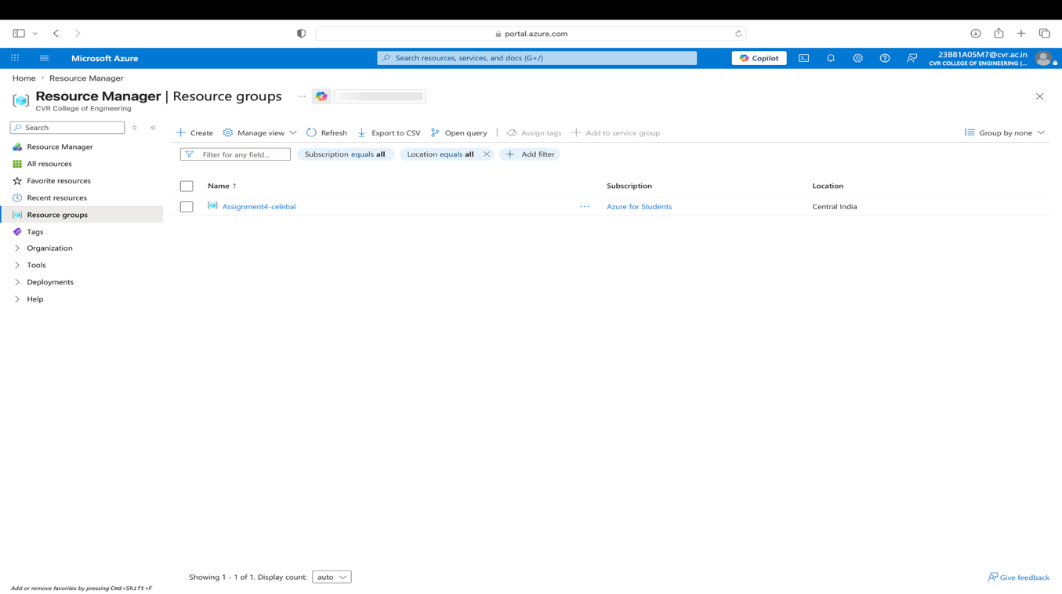
- I have explored the azure portal and created a resource group named Assignment4-celebal.

Task 2: Storage Setup
- Create a Storage Account
- Create a Blob Container
- Upload a CSV file

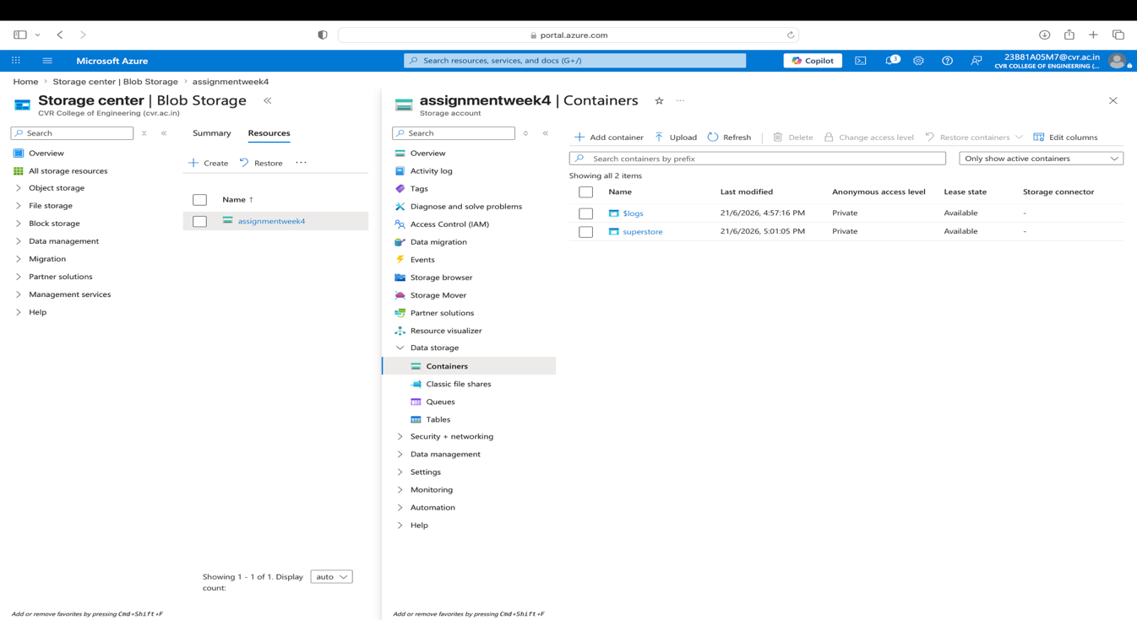
- I have created a storage account named assignmentweek4.
- Then in containers I created a container named superstore.

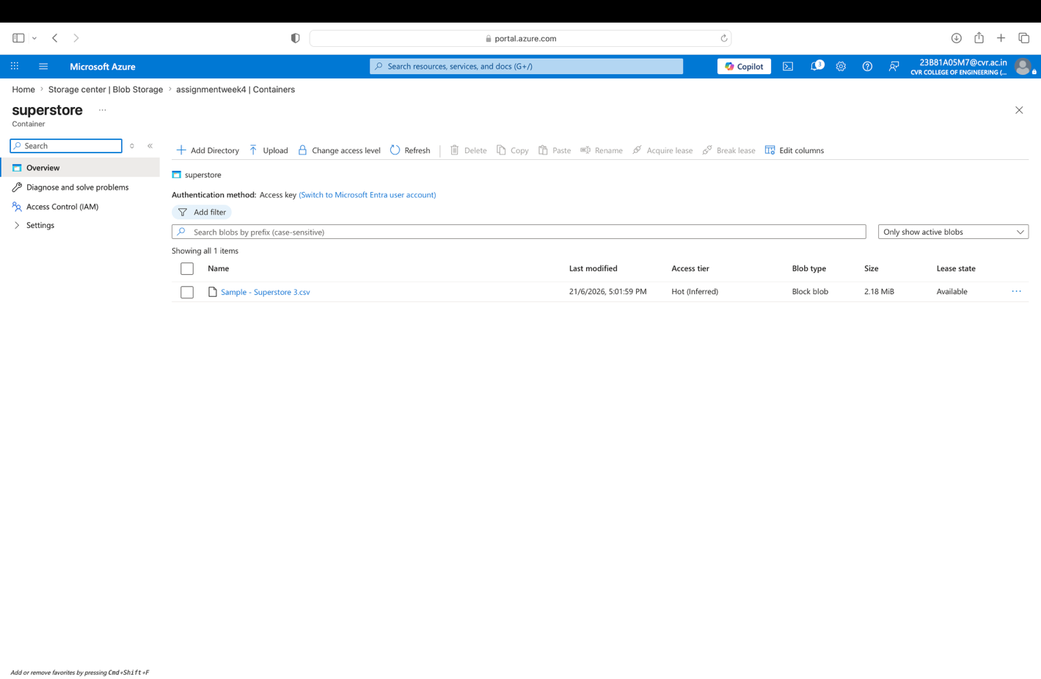
- In superstore container I have uploaded a csv file to store.

Task 3: ADF Basics
Do:
- Create Azure Data Factory
- Explore ADF UI (Author, Monitor, Manage)
- Create Linked Service (Blob Storage)
- Create datasets (source + destination)
- Use Get Metadata activity
Deliverable:
- Screenshot of Linked Service
- Screenshot of dataset
- Screenshot of Get Metadata activity
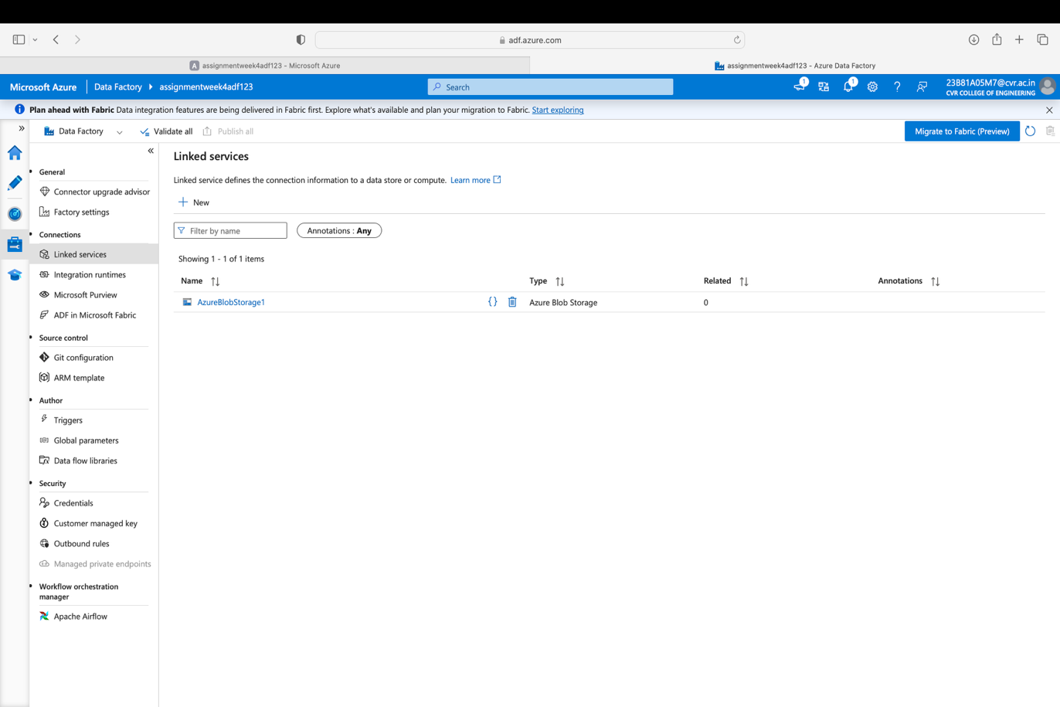
- I have created a linked service named AzureBlobStorage1.

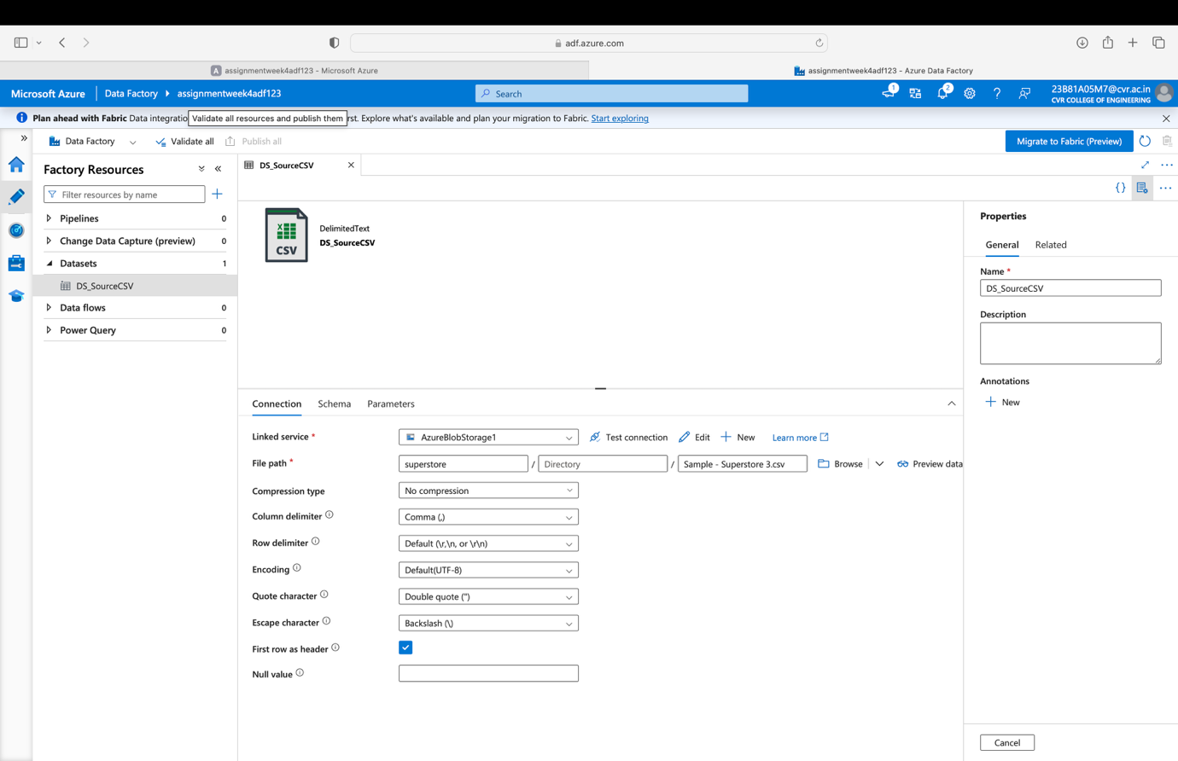
- I have created a dataset named DS_SourceCSV.

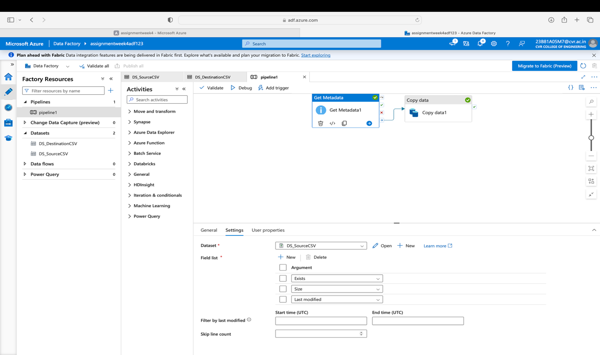
- The above screenshot is the depiction of the get metadata activity.
Task 4: Pipeline Development
Do:
- Create pipeline using Copy Data activity
- Configure source and destination
- Add ForEach activity (optional if multiple files)
Deliverable:
- Screenshot of pipeline design

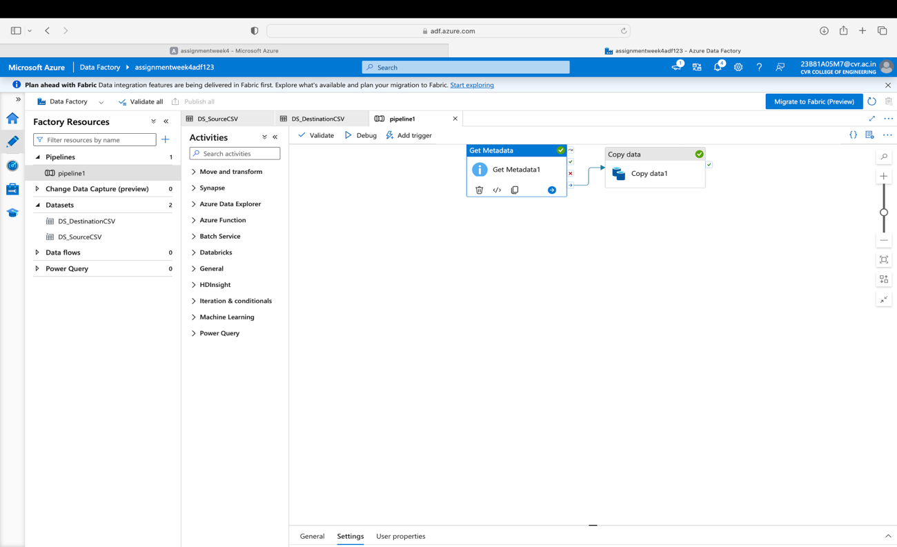
- The above is the pipeline design.
Task 5: Pipeline Execution
Do:
- Run pipeline using Debug/Trigger
Deliverable:
- Screenshot showing pipeline execution (Succeeded)

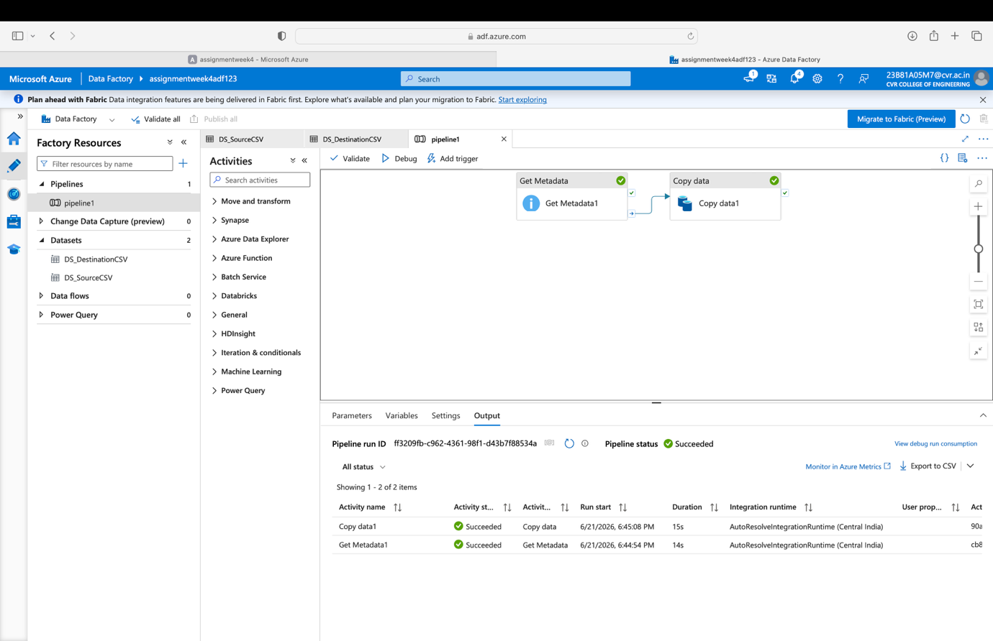
- I have debugged the pipeline and it succeeded.

Task 6: IAM Roles
Do:
- Assign roles:
- Reader
- Contributor
- Provide access to ADF for Storage
Deliverable:
- Screenshot of role assignment
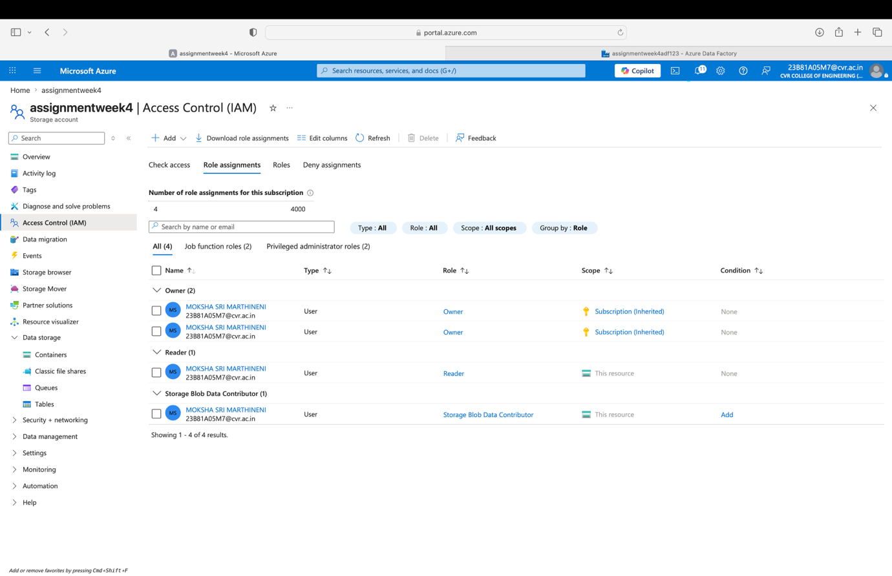
- I have assigned 2 roles Reader and Storage Blob Data Contributor.

Mini Project (Final Task)
Problem Statement:
Build a complete pipeline that reads a CSV file from Blob Storage and processes it using Azure Data Factory.
Requirements:
- Source: CSV file in Blob
- Use: Linked Service + Dataset + Pipeline
- Process: Copy Data + Metadata check
- Destination: New file/location
Expected Output:
- Pipeline executed successfully
- Data copied to destination
- Metadata validated


Screenshot of pipeline executed successfully.
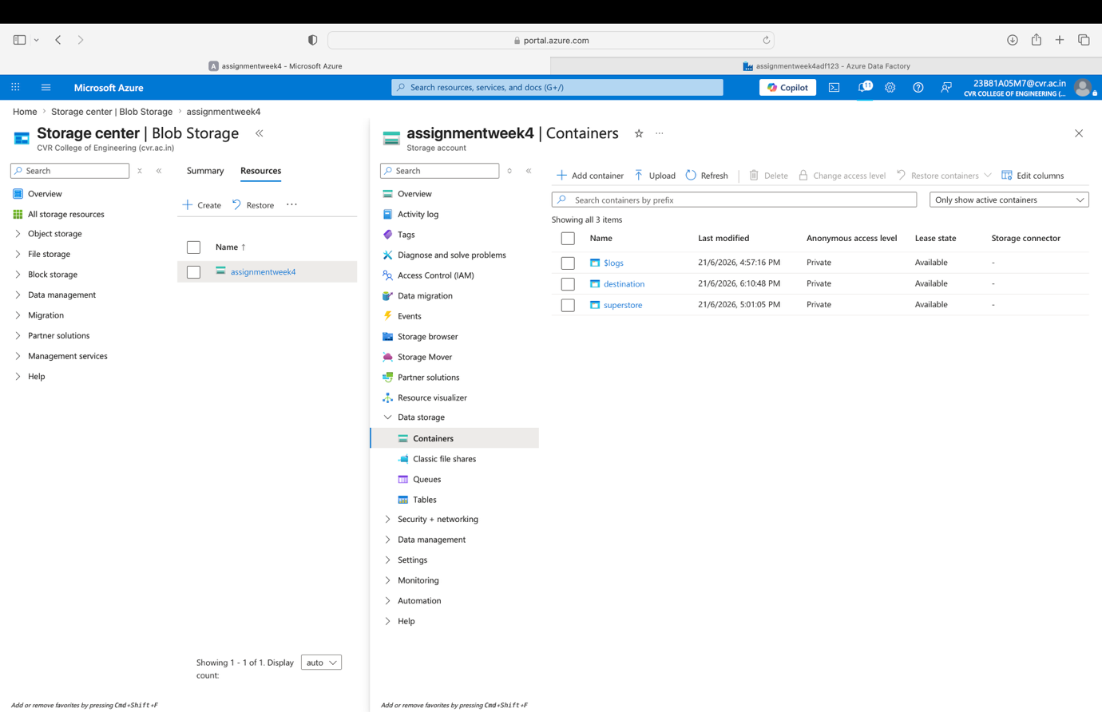
- The screenshot shows the destination container.
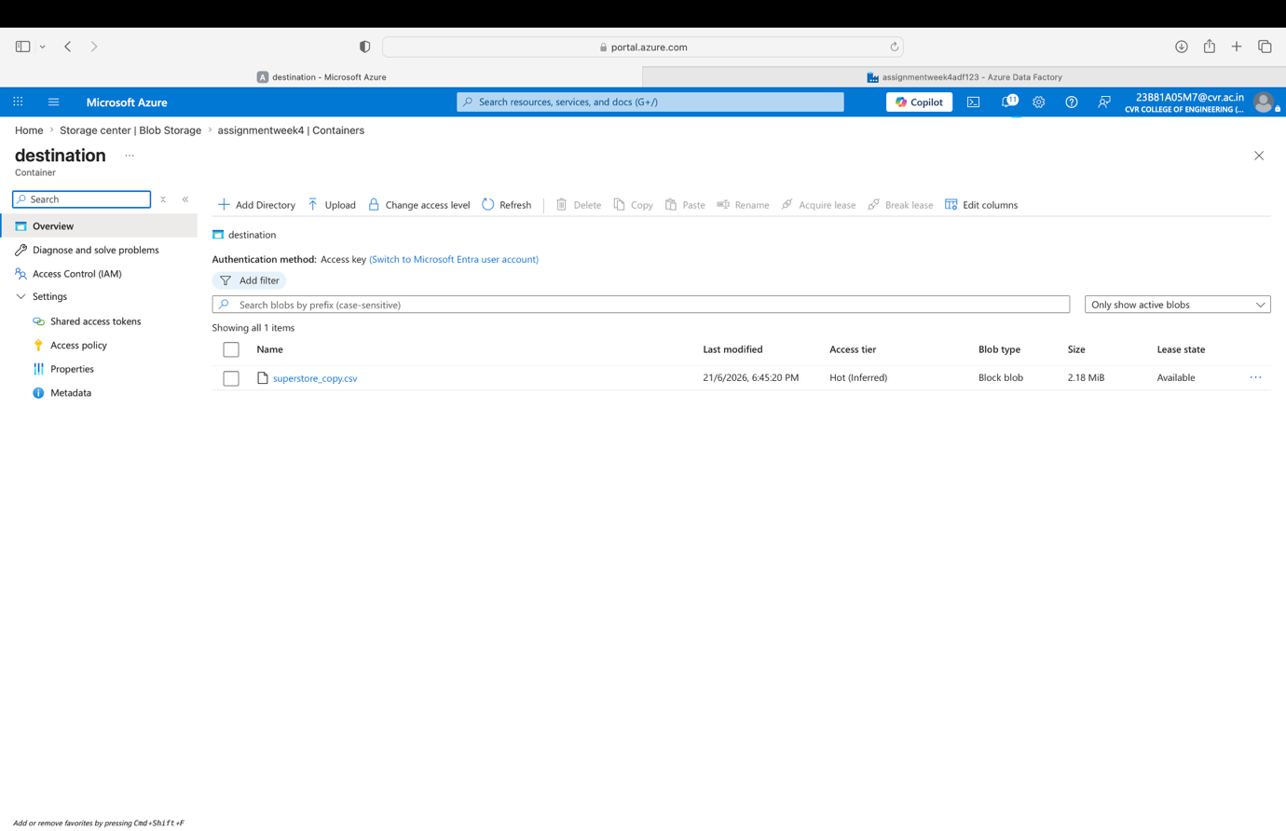
- The superstore_copy file is copied to the destination container after running debug.
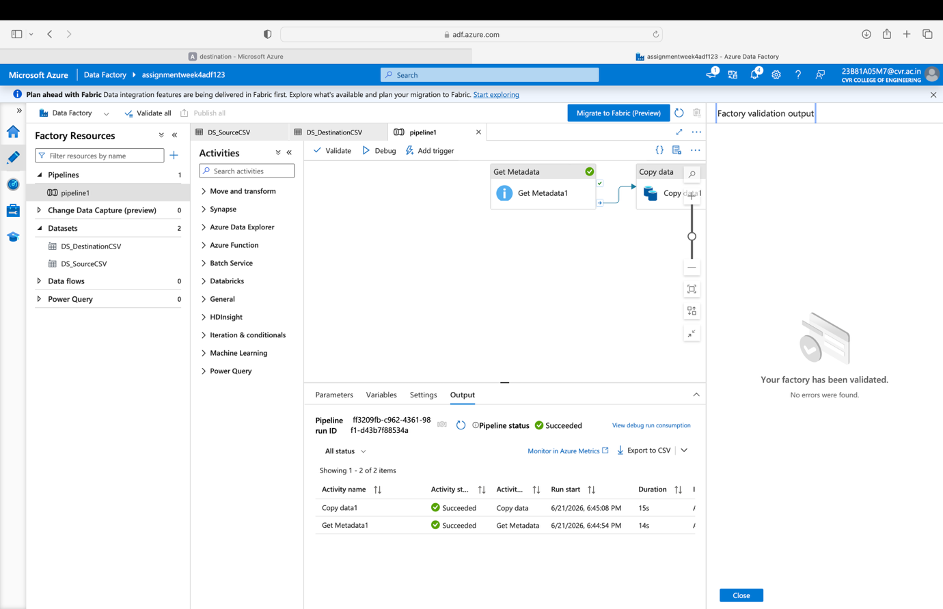
- This screenshot depicts that Metadata is validated

